Extracting polymer diffusion coefficients from scientific literature via bespoke LLM inference pipeline

Henry Varley, Robert Evans

Abstract

Contents
1. Introduction 1
1.1. The challenge of extracting polymer diffusion coefficients 2
1.2. Existing software 3
1.3. An LLM based solution 3
2. Solution 4
2.1. Design overview & success criteria 4
2.2. Implementation 4
2.2.1. ‘Extract’ 5
2.2.2. ‘Categorise’ 6
2.2.3. ‘Interpret’ 7
2.2.4. ‘Normalise’ 8
2.2.5. ‘Report’ 10
3. Results 10
4. Conclusion & Further work 10

- Introduction
Every year, millions of new research papers are added to the already vast library of scientific knowledge. Comprehensive literature indexing platforms such as Google Scholar are known to contain hundreds of millions of papers (Science) (Gusenbauer). Utilising this colossal amount of information is no easy task. Advanced search engines have been developed to select relevant works, however interpreting findings and extracting data remains a highly arduous and repetitive endeavour.
One of the issues in retrieval of relevant material is that current popular bibliographic databases have a somewhat shallow understanding of the actual content of the papers they store. For each paper, a limited set of metadata is held, for instance it’s title, authors, abstract and keywords. Scouring these databases for relevant data and information is crucial for researchers wishing to survey the literature adjacent to their field, so they can keep up to date with the cutting edge and utilise pre-existing findings in their work. This is a process that is notoriously time-consuming and error prone.
There are numerous challenges to overcome to utilise the scientific literature more effectively: one of which being representation. Some papers are now being stored and presented in Hypertext Markup Language (HTML), which allows the body of the paper to be read and understood by a computer. PDFs (Portable Document Format) are an unstructured form of data as the meaning we infer from them is retrieved optically: we interpret the symbols on the page as language and follow the writing and images with our chain of thought. This kind of representation does not lend itself to computer interpretation as there are no strictly defined relationships between different parts of the page. Characters are stored visually rather than as their symbolic counterparts, so their content is effectively “trapped” in a form that a computer cannot directly reason with.
Another issue is to do with semantics. To break apart and understand our archives of papers, a degree of computer understanding should be developed so that we can query papers based on meaning, and can begin to structure data in a form that can be harnessed immediately by scientists for use in their work. Efforts have been made to address this need for a semantic paper mapping, as surveyed by Keyan et al. (Keyan Ding), but submit to substantial limitations such as cross-disciplinary ontological alignment and access to complete context.
Essentially, locating relevant data is only a small part of the puzzle. Due to the aforementioned problems, maintaining a knowledge graph of high standard falls short due to the lack of interoperability between scientific data, preventing its homogenisation. This final issue is extremely problematic when trying to curate datasets from the literature, as it not-only requires a technical understanding of the science involved, but also the manual use of tools to unpick different transformations so that data can be combined. This paper reports the development of a pipeline for data extraction and the autonomous production of a dataset of polymer diffusion coefficients in the form of an Excel spreadsheet. The focus will be on the methodology and results and, importantly, demonstrate how these techniques can be applied to an arbitrary field of study.
  - The challenge of extracting polymer diffusion coefficients
The molecular weight of a polymer can be predicted using it’s diffusion coefficient which is acquired in standard DOSY experiments. The molecular weight is related to it’s diffusivity by the following power law including the empirically derived parameters c and v in the equation
$$D=c{M_{w}}^{-v}$$
The parameters c and v are determined experimentally and often reported in scientific literature. Locating tables of these coefficients, and extracting them for structured analysis, is an onerous task. Previously, efforts have been made to collate related diffusion data for the essential validation of scientific models, such as with Robert et al and their production of SEGWE (Evans, Poggetto and Nilsson). Their collection of 666 data points from 20+ papers was reportedly worked on for over two years by Evans and Poggetto, but despite their enduring efforts, an expanded corpus of data was required for verification of more accurate models. Hence the selection of these diffusion constants as the subject of this paper.
The way in which this information is presented in the scientific literature varies considerably, and are subject to gaps in contextual information, can admit a plethora of different mathematical transformations and reveal disagreements in symbology. For example, Hiller and Grabe denote the Flory coefficient with the letter b, whilst Voorter et al use the character v (Hiller and Grabe) (Voorter, Wagner and Rosenauer). Some authors may choose to refer to these constants instead with the column headings “slope” and “y-intercept” in the case of Nelson and Ward (Nelson and Ward) and others portray the information as a mathematical equation embedded into the table as with Chamignon et al, which can require mathematical manipulation to retrieve the desired numerics (Chamignon, Duret and Charreyre). Some tabulated data store very closely related, but different, quantities next to each other. In the case of Voorter et al, quantities b’ and c are in adjacent columns and is only through understanding their mathematical description in different parts of the paper through which the b’ value can be correctly selected as corresponding to the c constant described above (rather confusingly). This demonstrates the precarious nature of manual data selection, where even experienced scientists can make errors.
This data is not only highly unstructured in the literature, but it is encoded behind a wall of domain specific, contextual knowledge and scientific understanding. A vital aspect in its extraction is therefore the intellectual parsing of the context of the data tables; naïve pattern matching procedures do not work here. Consequently, conventional generation of knowledge graphs based on processing scientific papers verbatim are unlikely to be able to produce datasets that have highly specific output requirements such as those which require mathematical manipulation, a level of pre-processing or cleaning of the data.

  - Existing software
Scholars have demonstrated that LLMs can be employed as effective data retrieval tools when provided scientific texts, and this is currently a very hot topic when it comes to AI applications. Sadruddin et al, demonstrates a sophisticated solution `SciKGExtract`, a multi-stage agentic pipeline for scientific literature structured data extraction. Out of the box, the tool is suited for the extraction of ALD (atomic layer deposition) processes but can be manually reoriented to support extraction of other data. Additionally, it harnesses the PubChem database to find chemical name synonyms for semantic matching. Similar techniques have also been applied to materials science: Sayeed et al introduced `Knowmat` (Sayeed, Clark and Mohanty). The program employs LLM-as-a-judge techniques to request reinterpretations when hallucinations or clearly erroneous outputs are detected. It also captures raw extracted strings alongside the clean interpreted numerical values, which is extremely useful for manually validating correctness of interpretation of dirty fields. It does not however provide a generalised chemical name normalisation pipeline, instead relying on a manmade catalogue of material science property terms, somewhat limiting it’s versatility.
`The Librarian of Alexandria` expands the scope of the previously mentioned tools by attaching a paper retrieval process to the beginning of the extraction pipeline. This is an essential feature for an end-to-end, scholar-friendly data search program as it removes the arduous task of manually gathering papers.
  - An LLM based solution
Recent advances in agentic Large Language Models (LLMs) have proven themselves to be careful interpreters of information and sensible users of tools (Jansen, Liebenow and Schaller). Frontier models are now capable of in-depth reasoning and logical deduction, with extremely few errors. [EXAMPLE] Agentic models in particular are engineered to solve problems using a “chain-of-thought” structure, where the model is able to produce output text which it feed back to itself to continue it’s reasoning. This approach dramatically improves the reasoning capabilities of the model by allowing it to break problems up and experiment by pondering multiple approaches to answer the prompt. [FOR EXAMPLE?]
We are reaching a point where there is little reason to expect the best models to be incapable of understanding even the most technical research. Given the correct requests and compute access, researchers have started solving open problem that have stumped mathematicians for decades, such as the proof due to OpenAI of the Erdős unit distance problem, first proposed in 1946 (OpenAI). The problem then becomes how do we create the infrastructure and systems required to successfully utilise LLMs in order to create robust, error free and extensive datasets from the existing scientific knowledge. LLMs undoubtfully have the domain knowledge to correctly interpret scientific papers, and do not face issues of tiredness and impatience that a human researcher may face.
[NUMBERS] Access to the frontier models, however, is extremely excusive. LLMs contain tens of billions to trillions of parameters, which require expensive hardware and large-scale investment into the infrastructure to run them. Only a few companies in the world have the facilities to run these models, hence most AI researchers must purchase compute from these companies via an Application Program Interface (API). Thus, the aspect of cost comes into any discussion of the construction of AI-enabled software. It is important to keep in mind the spectrum of access to funding and hardware that researchers may have when developing tools that are intended to assist them. Indeed, it is possible to run open-weight models locally, on moderately capable hardware, such as NVIDIAs A100 graphics, which is what we targeted with this piece of software.
In this paper, we introduce “chemstractor”, an LLM-driven pipeline for extracting the chemical diffusion coefficients for polymers from scientific literature. We will demonstrate the techniques used in this software, detail each of it’s stages, comment on the results and how they can be generalised to produce tools that reliably extract and process different types of technical data. [SELL USP]

- Solution
  - Design overview & success criteria
The input to the program was expected to be a large corpus of PDF files, and the output to be a user-friendly and interactive Excel document of clean, validated coefficients, with some kind of graphing functionality. This autonomous presentation is key to demonstrate the convenience of the data aggregation system, and to fully capitalise on the data collected.
The primary limitation in mind during the development of this software was limited access to compute. The system was to be inclusive – with researcher’s budgets in mind. It achieves this by being primarily focussed on local LLM hosting and by taking a measured approach to prompting. Iterative development practices took place using local hardware to ensure that the program still worked effectively without the need for frontier models.
There was also an awareness of the performance of the application, as the intention was to execute the procedures on hundreds of scientific texts. Whilst the execution of this program is primarily a one-time event – scientists run it on their corpus, the data is retrieved, and they continue – an execution time of around 5 minutes per paper was sought. This was to accelerate development by allowing faster iterative improvements of results, and to provide an enhanced user experience.
An important non-goal for the application was for it to be a generalised tool for chemical data extraction. Whilst this is an extremely desirable goal for the wider scientific community, this project decided to focus on accuracy, speed, coverage and worked on an accelerated development timeline. In return, an extremely useful dataset was produced in a relatively short amount of time, which is intended to be put straight to work on new science. Additionally, this paper describes ways in which the powerful techniques used can be converted to work for other scientific readings and even generalised for use on novel types of data.
  - Implementation
“Chemstractor” is a command line tool written in Python. It uses the `click` library in order to convert it’s functions into sub-commands that can be run on the command line. It also uses the library `rich` to display a modern, colourful terminal-based user interface, including tree structures and loading bars. The user interacts with the different stages of the extraction pipeline by running these different commands, which are provided in singular (extract, process), and bulk (extract-all, process-all) options.
`process-all` is the most important command in the application. It takes as input a folder of PDF files and runs the entire extraction pipeline on each file sequentially. Each processed PDF is given an output folder, where all extraction information is stored relating to that file. Different stages of the extraction pipeline can therefore be run separately, as dependencies can be loaded at any time from the clearly defined file structure. This ability to separate the stages of the pipeline tremendously improves development and testing of each process.
We will now detail each stage of the extraction pipeline.

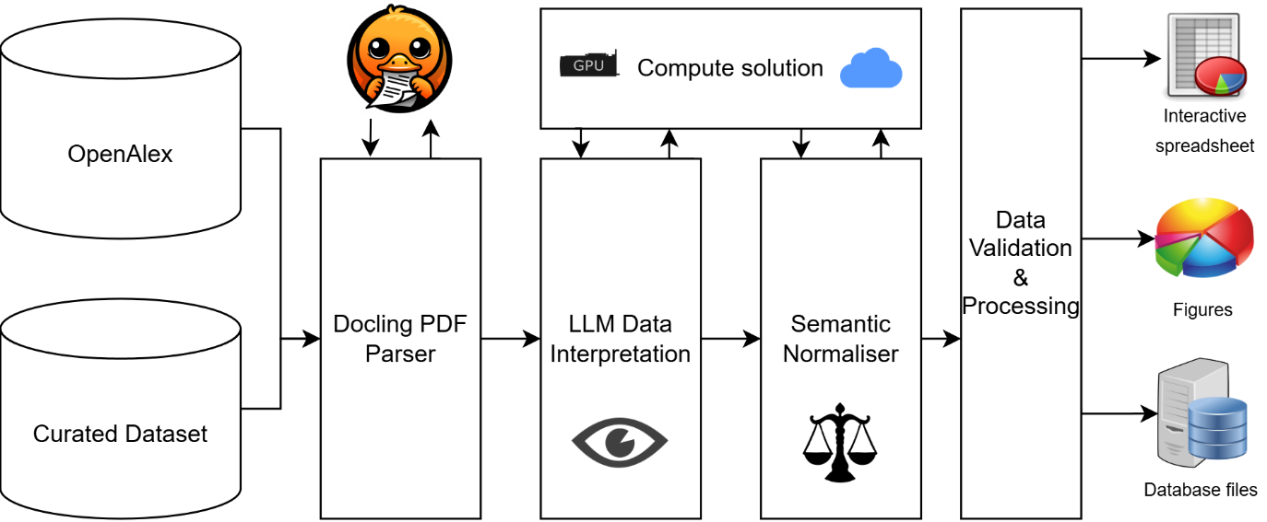
Figure 1: Macro scale design of "Chemstractor"

‘Extract’
The first stage in processing a scientific paper in PDF form is to convert it from its embedded vector format into something more machine readable: UTF-8 characters. There are many tools emerging that are capable of doing this, as it is one of the best ways to allow a Large Language Model to understand visual articles.
Modern parsing libraries include a muti-faceted suite of tools that allow the breakdown of unstructured documents such as PDFs into structured text. Principle to this process is the OCR: Optical Character Recognition. This is an AI model that specialises in the recognition of characters. Additionally, these libraries have advanced sub-processes that analyse reading order, convert equations into LaTeX, and vitally, accurately extract table structure and content.
For this task we chose the library `docling` (Livathinos, Auer and Lysak). This was for a few reasons, but primarily, it’s reported high accuracy when extracting table structure and content, for its popularity and due to its high development activity, which indicates it will be kept up to date with the latest capabilities. Docling produces a markdown file, which is a character encoded document which withholds certain structural aspects commonly found in files, such as headings and tables. LLMs work with text natively, so these files can be passed directly to them in the form of a prompt.
Before that, however, a number of processing steps are executed on the markdown output in order to improve the LLMs accuracy and reliability. One of the goals of this software was for it to be compatible with lower-tier models, known as “open-weight” models, that can be run on locally sourced hardware. One of the trade-offs for using these models is that they use fewer parameters, and often have stricter limits on the number of input tokens they can manage at one time, known as the “context window”. It has also been shown that retrieval oriented tasks suffer accuracy shortcomings when the LLM prompt is exposed to excessive input length (Du, Tian and Ronanki), and that they suffer from “distraction” when relevant and irrelevant information are presented adjacently (Huang, Wang and Xu). For these reasons, papers are split into “table fragments”, which are smaller markdown files that include the table, and a controllable number of proceeding and trailing paragraphs taken from around that table.
This architecture is intended to limit the number of potential distractions for the LLM, and essentially simplify its job by allowing requests to focus directly on the table and it’s context rather than rely on the LLM to do this itself. It also admits a degree of encapsulation so that only relevant tables are selected for further processing, decreasing paper processing time.
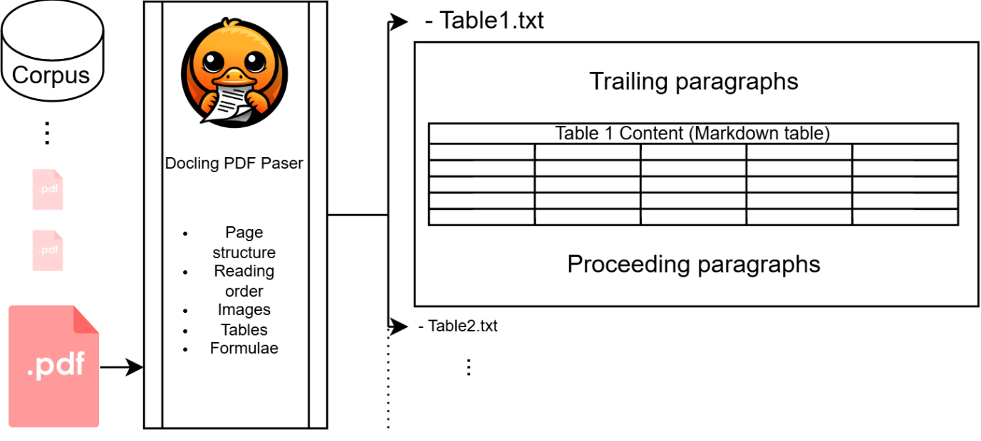
Figure 2: The extraction proces. Papers are analysed by docling and split up into induvidual table files. When there are tables near eachother in the paper, these are omitted from the contextual information.

‘Categorise’
Now that tables are neatly arranged in their own files, a categorisation procedure can take place. This stage is responsible for flagging tables that contain the data we are looking for.
Note that this stage could have been combined with the subsequent step. There are a few advantages to splitting this stage into it’s own prompts. Firstly, it makes the relevance checking a lot more predictable and testable, as we can run the ‘categorise’ command independently of the ‘interpret’ step (which is a more compute-intensive procedure). By flagging if a table contains the relevant information before it is interpreted and has it’s data extracted, we save a lot of compute by skipping irrelevant tables altogether. It also allows us to inspect precisely why a table may be considered wrongly for data extraction.
Categorise works by simply providing the AI with each table fragment and asking it a few simple yes/no questions about the material. These questions were constructed to be intentionally simple so the AI had less chance of getting it wrong. A logical combination of these answers was used to decide whether a table should be flagged for further extraction.
The output of the AI’s response was formulised using a `pydantic` schema, which creates strict output requirements for the LLM in the form of a key-value pair structure. It also restricts the value part of the output to a specific data type, in our case a Boolean, so that the result can be flawlessly interpreted by the code.
For our requirements, we created five questions:
- `contains_experimental_data`: Used to filter out summary statistics and other quantities that are not derived from chemical processes.
- `contains_raw_diffusion_data`: Used to select for diffusion readings
- `contains_mark_houwink_parameters`: Used to select for Mark-Houwink parameters
- `contains_flory_parameters`: Used to select for Flory parameters
- `contains_polymer_diffusion_coeff`: Used to specify that we only want data that relates to polymers.
Each of these criteria had additional explanation added to make it absolutely clear to the LLM when and when not to mark each field as true, this can be found in the SI.
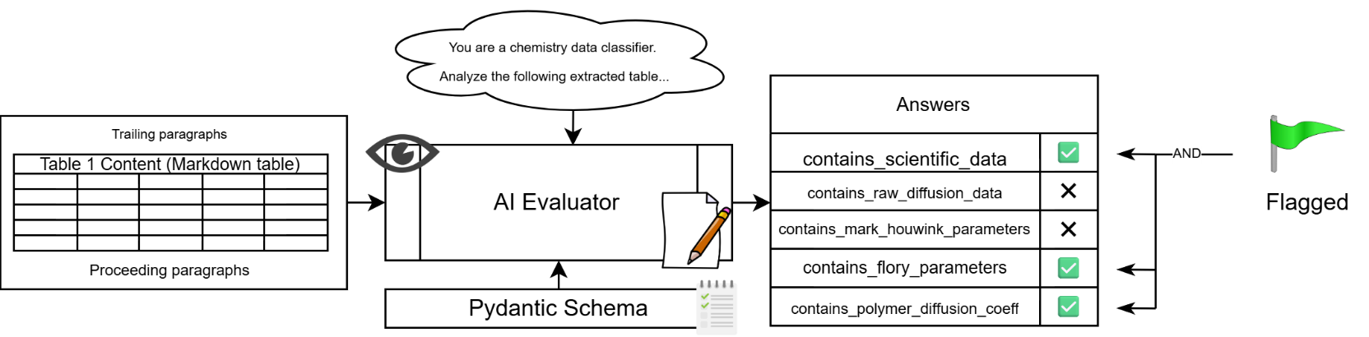
In this case study, we decided to flag tables for extraction if their categorisation result yielded true for criteria 1 and 4 and 5. Criteria 2 and 3 were included to demonstrate the flexibility of the system to other types of data. Pivoting the algorithm to search for Mark-Houwink and diffusivity readings would be as simple as altering the flagging predicate to require their result to show true.
Figure 3: Demonstration of the categorisation process. The LLM is provided the table and its context and asked a series of Boolean-answered questions.

Flagged tables are then passed to the next stage of extraction.

‘Interpret’
This is perhaps the most important stage in the pipeline: ‘interpret’ is where the data is taken from each table and arranged into a structured form.
This works by again handing the table fragment to the LLM and asking it to select the relevant data. A Pydantic schema was defined for this extraction, so that the output was in a reliable form and we did not have to hope the AI responded in the expected way. The most important fields in this schema are as follows:
- `polymer_name`
- `solvent`
- `v_value`
- `c_value`
Each field was given a specific delineation for what the model was expected to leave there, long with a main prompt that provides detailed information about what to extract, what to avoid, and how to respond when the outputs were unclear.
One of the most important instructions to give the AI is a “Not found” or “Unsure” option. Hallucinations are caused when the model attempts to answer something that it does not know the answer to, so instead provides a response that sounds reasonable but is actually nonsense [CITATION]. By explicitly telling the AI that it does not always need to respond with a numerical answer, hallucinations can be avoided.
These prompts were developed iteratively by observing the effectiveness of this interpretation stage and tweaking the instructions to accommodate for general edge cases. Direct feedback from the subject matter were of course avoided, heuristic but numerical guidance was given to encourage the model to correctly reason with the input accurately. One may argue that this kind of assistance spoils the purity of the extraction process and makes implausible the potential for creating a generalised chemical extraction system, however this may not actually be the case as argued in section [SECTION LATER].
One of the principal challenges of this specific data extraction is that the information in the tables can transformed in numerous ways. For instance, sometimes the equation is written as $D=c{M_{w}}^{-v}$and other times as $D=c{M_{w}}^{v}$, with the assumption that $v$ is a negative number. These kinds of discrepancies posed a high risk to pollute the dataset, or require the removal of a large quantity of the data collected. For this reason, the LLM was given access to a ‘calculator tool’, in the form of a Python function, and instructed to use it to try and untangle these transformations. Successful tool access is very much to the discretion of the AI (as opposed to the deterministic output formatting provided by Pydantic), so use of the calculator tool was highly stressed in the LLMs system prompt (“You are a precise chemistry data extractor. You must NEVER do math in your head.”).
Dedicated fields in the Pydantic schema were provided for the LLM to list the raw extracted value v and c values from the table, and any transformation it may have applied to those numbers. This was primarily done for checking for erroneous outputs.
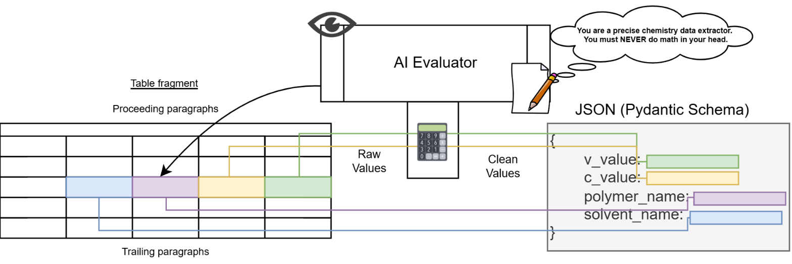
Due to the ‘categorisation’ layer before this, it was rare to see the interpret phase having to handle a table that did not contain at least some relevant data for our search. We believe that this substantially cut down on hallucinations, even on the small open weight models used.
Figure 4: Diagram demonstrating the interpretation process. This is called interpretation rather than something like "selection" because the LLM needs to make measured decisions about how to manipulate the data into the correct format rather than simply selecting it.

Once this process is complete the data is in a structured, computer-operable form, a list of JSON objects. However, the usability of the data is still low due to one crucial problem: chemical names. The next stage attempts to clean the data and allow for use in an Excel report.

‘Normalise’
Rightfully, scientists use different terms for the same chemical. Examples include the case of historical semantics, like with the (lack of) difference between poly(ethylene glycol) and poly(ethylene oxide), or, most commonly, use of acronyms in place of longer chemical names. PMMA for poly(methyl methacrylate) for instance.
To be able to automatically construct a database where all references to identical chemicals are considered the same, semantic and symbolic differences must be detected and a single “canonical” name must be chosen for each chemical. In addition to the types of differences mentioned above, there is also the issue that to the computer, chemical names that differ trivially from one another are not immediately identified as the same thing (“pMMA” vs “PMMA” for instance). Whilst hardcoded normalisation, such as setting all characters to lower case, can be manually implemented to remedy issues such as this, a more general solution was needed that could flexibly handle the myriad of formatting and naming differences. The solution presented is also capable of detecting syntactic hallucinations that can be produced from the “extract” and “interpret” stages.
The puzzle is twofold: we must decide on shared canonical names for chemicals, whilst also filtering out erroneous entries. To do this, a cache is created in the form of a JSON file to store chemical names, where the key is a raw chemical name and the value is a chosen chemical name.
Each chemical name goes through a three-stage process in order to either decide on one of the preexisting chemical names, or to create a new clean chemical name for that input. The first check made is a direct match to the chemical match. By using fuzzy string matching on the keys of the JSON object, a direct match to the cache can quickly be found and final name decided. If no match is found, an LLM is employed to attempt to match the chemical name to one of the preexisting names semantically, that is, by it’s meaning rather than its name. This stage is designed for the common scenario where we wish to match PS to “polystyrene”; the string is nothing similar, but they refer to the same chemical.
In order to guarantee the LLM produces a chemical name strictly in the list of clean chemical names, the list of values from the JSON cache is converted at runtime to an enum type which is directly passed as the required chemical output type in the Pydantic schema.
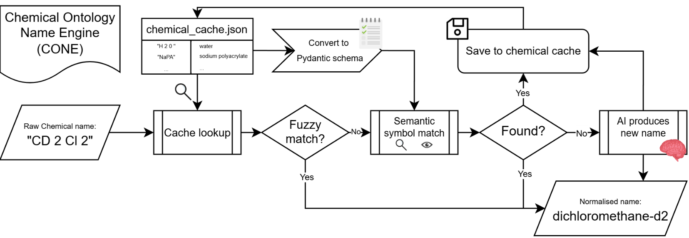
In the previous step, the LLM is given the option to return the result “No Valid Option”. In this case, the algorithm has finished trying to match the chemical to an existing name decision. Another LLM is prompted and given careful instructions to create a new normalised chemical name for the given input string. The AI is also given the option to refuse to name the chemical, if what it has been provided is some kind of hallucination or not clearly identifiable as a chemical. This implementation of the algorithm also chooses to run some case specific filtration during this process. Our desired outputs consist only of chemicals. Other chemistry related, but not specific chemical names, such as “globulated proteins” are unwanted and hence general advice was given in this naming process to reject these cases. This procedure is depicted in the following flowchart.
Figure 5: Flow for chemical name normalisation algorithm

It is important to note that for our purpose, the algorithm constructing it’s own ontological domain is perfectly acceptable as the data is intended for manual handling, without the need for computer comparison with other datasets. Similar programs are known to use external sources of truth to construct datasets compatible with other services [CITE]. This algorithm can be altered to accept predetermined ontologies by simply preloading a library of chemical names into the cache.

‘Report’
Now that a chemical vocabulary has been established and like terms have been gathered, the last stage is to simply wrangle and output the data in the desired medium and arrangement.
Before this however, a final sanity-check process is undertaken in which heuristic guard-rails are executed on the numerical results. For the case of polymer diffusion coefficients, we expect the value $\log{D}$, to be in the range $-9±3$ and for the v value to lie between $1$ and $\frac{1}{3}$. Table entries with values outside of this are likely to have fallen victim to an incorrect mathematical manipulation, and are excluded from the final dataset, but flagged and reported for further inspection.
The primary output material we chose for this application was a multi-sheet Excel document. One of these sheets was intended to be the “user-facing” final resource produced by this experiment. This was an interactive page where one is presented with two dropdowns, one for polymer and another for solvent, whereby selection of a pair automatically filters the data and produces a plots the log-log graph. This document serves as a powerful resource for chemists to use in their research and proceed with polymer science free of the burden of having to collect this data manually.

- Results
We will now discuss the effectiveness of the developed algorithm at correctly extracting polymer Flory constants from scientific literature.
  - Corpus
These results will focus on the output of the program run on a large corpus of 232 scientific papers. These papers were sourced from two locations. 119 of them were hand curated by us, via numerous means. They have a high degree of relevance thanks to the meticulous nature of our search. The remaining 113 were gathered using the OpenAlex API, which is a large and free web of academic artifacts that can be queried and navigated through (Priem, Piwowar and Orr). The search term “Polymer Diffusion DOSY” was used, paper types and subjects were filtered down to only result in relevant chemistry material. Unfortunately, due to the highly specific nature of what we are trying to search for, it is difficult to configure a search that retrieves results that are a similar level of specificity as the hand-picked option. Regardless, these papers still served as important checks for false positives in the run.
Together, this collection of papers was intended to stretch the LLMs capabilities by providing a breath of relevancy, including data tables that contain information that is incredibly close to what we want. Most notably of which are tables containing rows of a polymer at different lengths, and some statistic about them such as diffusivity. This kind of data runs tangential to the curve fit parameters as it is this data which the curve is fitted to; it is the step before and thus can be easily confused [ROB CHECK] [CITATION?].
  - Summary statistics
The run was executed on a high performance node at the University of Manchester’s Computational Shared Facility 3 server. The process was run as a slurm batch job that simply ran the python command to process the entire corpus. The slurm batch file was configured to use 4 Intel Xeon E5-2690 Cores with 24GB RAM, and a single NVIDIA HGX A100-SXM4-80GB GPU.
The pipeline was split into two parts. The first was the main processing stage, which extracts, categorises and interprets all valid tables. This took a total of 9h 7m 51s for all 232 papers, giving an average of

- Conclusion & Further work
The strong results from this study and its counterparts indicate that the creation of a truly universal AI-enhanced scientific information extractor is now an engineering challenge, rather than something residing in the bleeding edge of AI research. LLMs certainly have the inference skills to enable them to correctly retrieve, organise and validate datasets derived from chaotic scientific literature, it is now our job to construct the necessary infrastructure to allow them to do this.
That being said, the plethora of types and formatting of extractable information poses a huge challenge for engineering a single do-it-all pipeline. Inflexibility is occurring in pre-existing systems when output expectations are too rigidly defined for one specific type of data, and extraction instructions are similarly specific. Exact schema requirements are oftentimes too technical to be constructed directly by end-users, hence LLMs can be used to construct schemas directly from texts and natural language provided by experts, as demonstrated by Sadruddin et al (Sadruddin, D’Souza and Poupaki).
We suggest that to provide the necessary flexibility for a universal tool, a large amount of LLM with human-in-the-loop fine-tuning could be utilised to essentially create a custom extraction pipeline for each use case. This could involve not only the AI-assisted creation of the extraction output schema, but also the direct modification of the LLM prompts at different stages of the pipeline. The program presented here has hard-coded prompts modified via manual feedback from erroneous outputs to achieve high accuracy for the relevant material. A feedback-cycle where (1) the AI writes more detailed extraction prompts (based off the user query) (2) the system produces some values and (3) the expert gives feedback for the AI to again refine the prompts, could achieve large-scale coverage and dramatically reduce errors reaching the final dataset.
Certain roadblocks to a universal data retrieval tool are up to the wider scientific community to tackle, primarily, the limitation of paper access. The way we access academic documents is currently far too fragmented and restrictive to allow for any tool to optimally harness humanity’s scientific output. Additionally, authors should be encouraged to adhere to FAIR (Findable, Accessible, Interoperable and Reusable) (Wilkinson, Dumontier and Aalbersberg) data stewardship principles, so that computers can access information seamlessly. Ideally, all significant research artifacts such as tables and graphs should have their raw data stored in structured data files and uploaded to journal hosting sites in a similar way to supporting information. Undeniably, achieving homogeneity in the way we store and retrieve our scientific findings will require a significant rework of how the publishing process works, however it is a worthwhile endeavour that will eventually save scholars large swathes of time for years to come.

